# Exercises: Spring Essentials

Problems for exercises and homework for the [“Java MVC Frameworks - Spring” course @ SoftUni](https://softuni.bg/trainings/1538/java-mvc-frameworks-spring-march-2017).

## Add Users

Add feature that allows users to be **registered** in the system as well as **logged in** and **logged out.** The logged in users should have **several privileges** that not logged in users should be restricted. These privileges are described in the tasks below.

To register users should provide **email**, **username** and **password**. To log in the user must provide **username** and **password**. Once logged in he can log out.

## Change Permissions

Right now, every visitor of our web application can **add new cars**. Restrict that feature only to **users that are logged**.

## Add Sales

The logged in users should have option to **add sales**. A sale requires the user to choose **car** and **customer**. Also, the user should specify the **discount percentage** of the sale. After the user fill out the form when he submits it, he should be **redirected** to a page that shows **summarized information** for the sale:

* customer **name**
* car **make** and **model**
* total **discount** percentage
* **price** of the car **before/after applied discount**

On that page, there should be a button that **finalizes** the sale and **add it to the database**.

Note that if the selected customer is young driver **additional 5%** should be added to the **discount** percentage.

Once a sale is added to the database it should **not** be able to be **edited** or **deleted**.

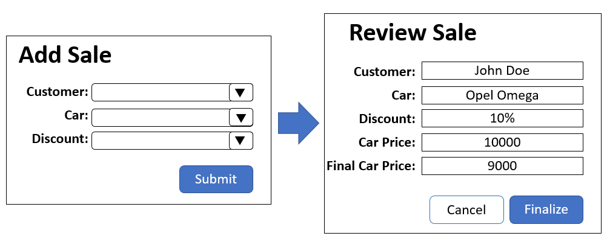

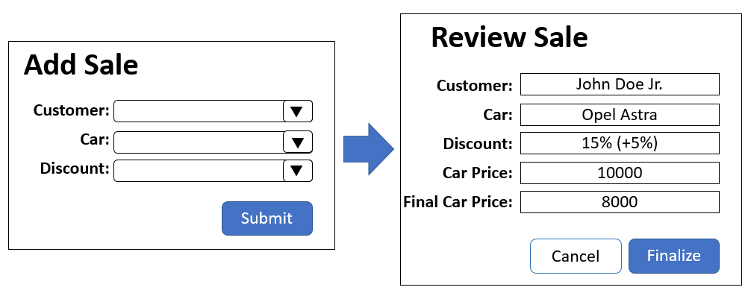

## Add, Edit and Delete Suppliers

Add functionality to the logged users to **add**, **edit** and **delete** suppliers to/from the database. When supplier is deleted all of his parts should be deleted.

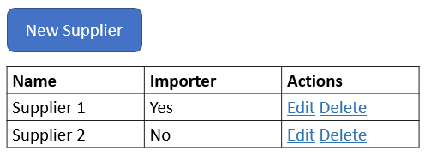

## Logger

Every time a user adds a car, sale or **add/edit/delete supplier** that action must be logged in the database in table

* **Logs** 
  + User
  + Operation - add, edit or delete
  + Modified table name,
  + Date and time of modifying).

All logs should be visible by logged in users on {host}/logs/all. The logs should be sorted by date ascending. The users can **delete** these logs

The page showing all logs should have also the following functionalities:

* Show **all logs for given user** by providing username
* **Clear** all logs from the database

